**Definition: Design Visiting card using different drawing and images tools. (front-side and back-side)**

**Solution:**

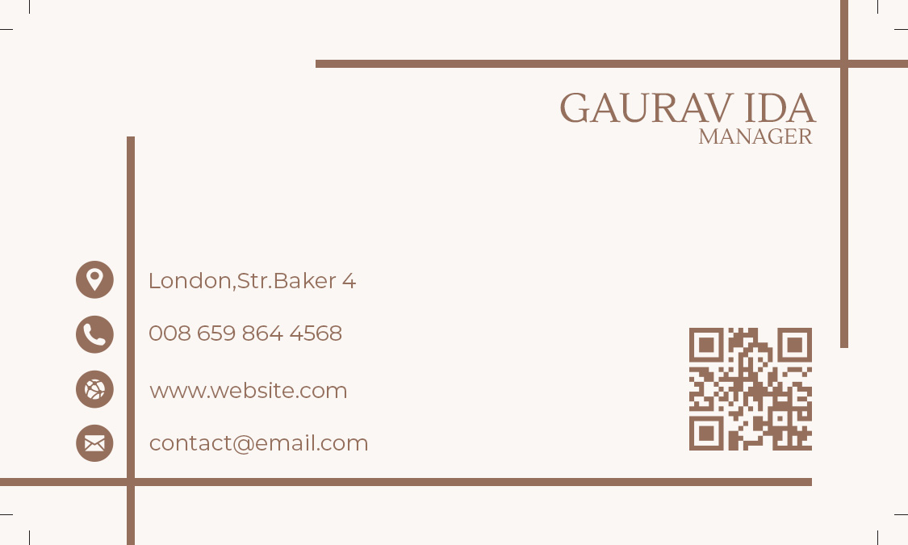

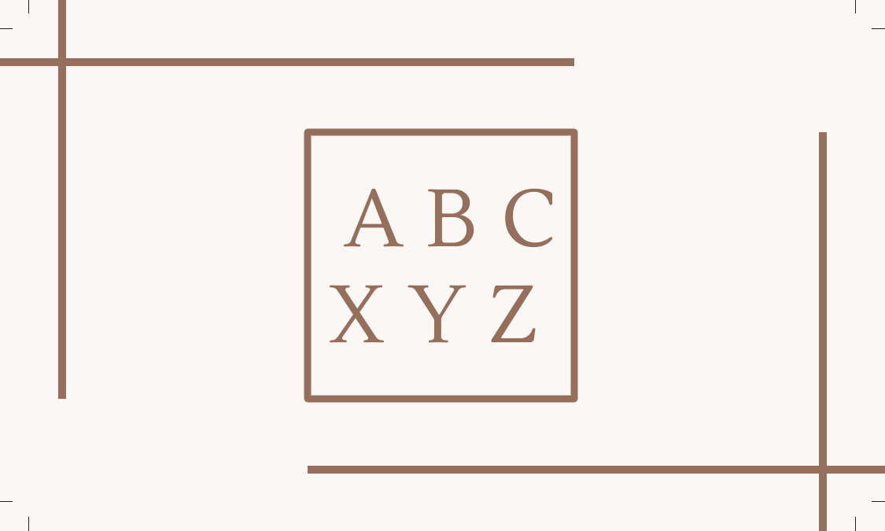

**Steps:**

* First Open photoshop.
* Then create the new document **File à New Photoshop Design.**
* Now add take one frame using the Frame tool and select a Desktop frame of width=”**1125 px**” and height=”**675 px**” on your canvas.
* **TO MAKE FRONT SIDE:**
* Take a background image like above front side image.
* Take Horizontal Type Tool and write “**GAURAV IDA**” of font=”**Lustria**”, font size=”**12 px**” and color=”**#956F5C**”.
* Under the Type Tool write “**Manager**” of font=”**Lustria**”, font size=”**6 px**” and color=”**#956F5C**”.
* Now on the bottom-left side of the line add following icons: **Location, Contact, Website, Mail**
* Add description of those icons on the right side of the line of font=”**Montserrat**”, font size=”**6 px**” and color=”**#956F5C**”.
* Lastly, place an image of QR code on the bottom-right side of image.
* **TO MAKE BACK SIDE:**
* Take a background image like above back side image.
* Now take and Rectangle of width=”**1150 px**”, height=”**250 px**”, color=”**#FFFFFF**”, stroke=”**1 px**” and stroke color=”**#956F5C**”.
* Inside the Rectangle write **“ABC”** of font=”**Lustria**”, font size=”**24 px**” and color=”**#956F5C**” using Horizontal Type Tool.
* Now under the Type Tool write **“XYZ”** of font=”**Lustria**”, font size=”**24 px**” and color=”**#956F5C**” using Horizontal Type Tool.
* Now, Go to **File à Save As** and save it with **.PSD/.JPEG/.PNG** format.